PANDAS PROGRAMS

1.Creating Data Frames

AIM : To write a Python program using the Pandas library to create a DataFrame from a dictionary and display the first rows, information about the dataset, and its statistical summary.

ALOGITHM :
- Start the program.
- Import the Pandas library using import pandas as pd.
- Create a dictionary containing the columns Name, Age, and City.
- Convert the dictionary into a DataFrame using pd.DataFrame(data).
- Display the first five rows using df.head().
- Display the DataFrame information, including column names, data types, and non-null values, using df.info().
- Display the statistical summary using df.describe().
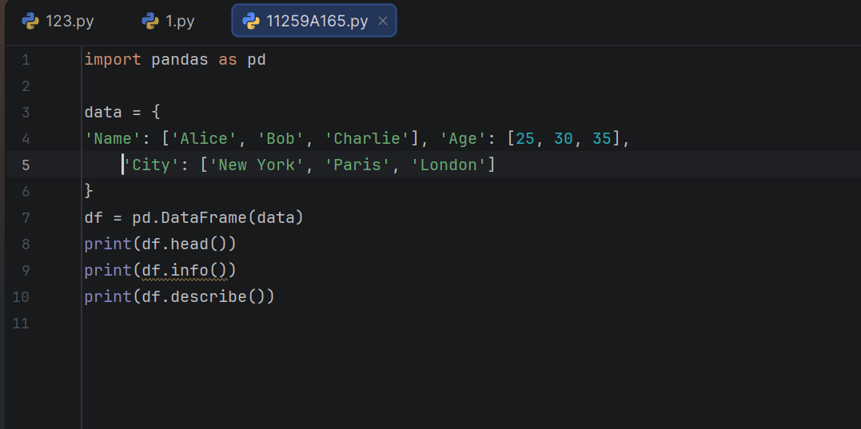
- Stop the program.

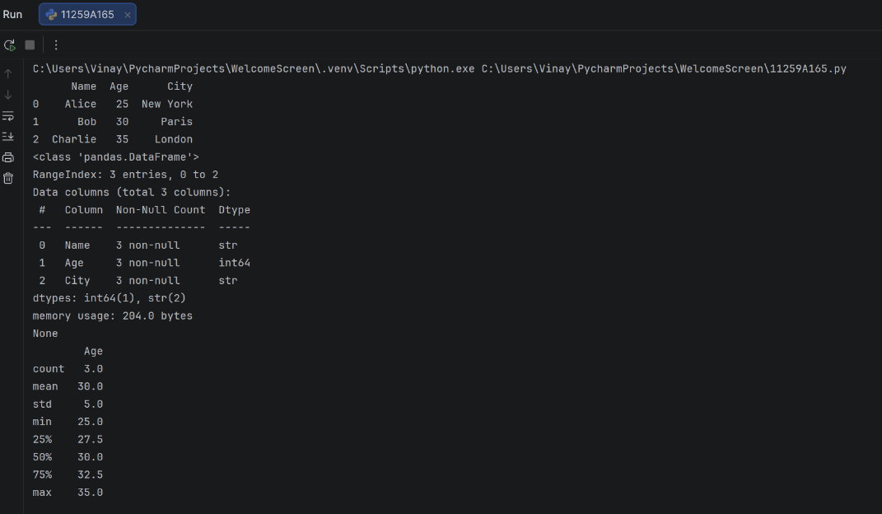

RESULT : The program successfully creates a Pandas DataFrame and displays its contents, data types, non-null counts, and statistical summary.

2.Selection and Filtering

AIM : To write a Python program using the Pandas library to select a specific column, filter rows based on a condition, access rows using iloc, and retrieve a specific value using loc.

ALGORITHM :
- Start the program.
- Use the existing Pandas DataFrame df containing the columns Name, Age, and City.
- Select the Age column using df['Age'] and display it.
- Filter the rows where the age is greater than 25 using df[df['Age'] > 25].
- Access the first row using integer-based indexing with df.iloc[0].
- Retrieve the name at row index 0 using label-based indexing with df.loc[0, 'Name'].
- Display all the results.
- Stop the program.
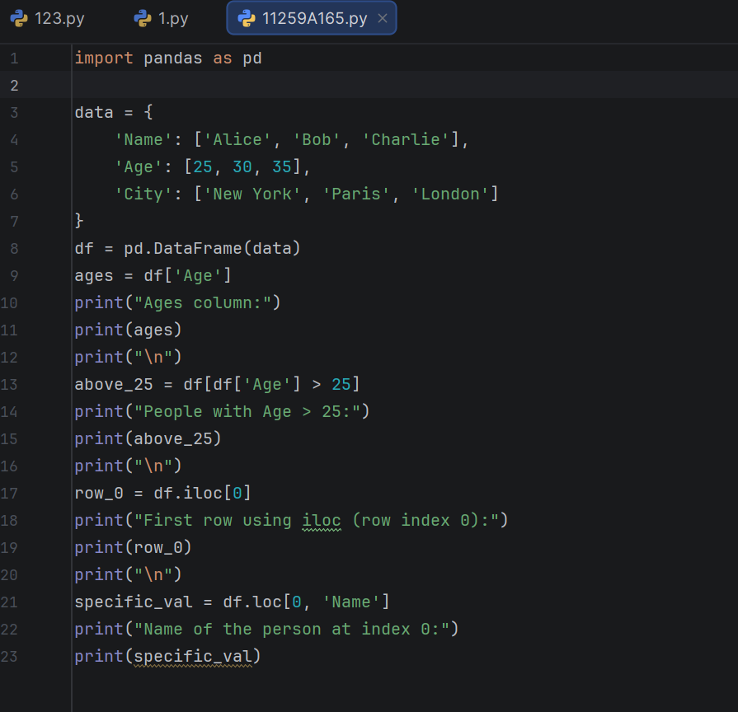

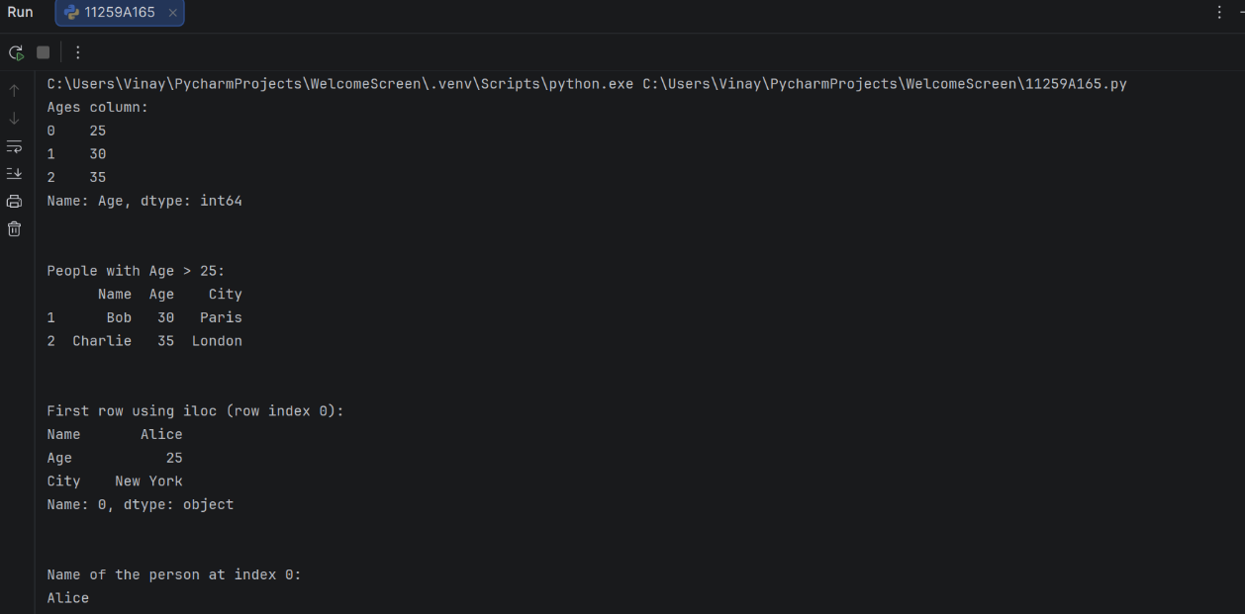

RESULT : The program successfully demonstrates column selection, conditional row filtering, integer-based indexing using iloc, and label-based value selection using loc in Pandas.

3. Data Cleaning (Handling Missing Values))

AIM : To create a Pandas DataFrame containing missing values and perform data cleaning operations by identifying null values, removing rows with missing data, filling missing values with zero, replacing missing numerical values with the column mean, and replacing missing categorical values with a specified string.

ALGORITHM :
- Start the program.
- Import the Pandas and NumPy libraries.
- Create a sample dataset containing the columns Name, Age, and City, with some missing values represented by NaN.
- Convert the dataset into a Pandas DataFrame.
- Display the original DataFrame.
- Check and display the number of null values in each column using isnull().sum().
- Remove rows containing missing values using dropna() and display the cleaned DataFrame.
- Fill all missing values with zero using fillna(0) and display the updated DataFrame.
- Create a copy of the original DataFrame and replace missing values in the Age column with the mean age.
- Display the DataFrame after mean-value imputation.
- Create another copy of the original DataFrame and replace missing values in the City column with "Unknown".
- Display the DataFrame after filling the missing city values.
- Stop the program.
PROGRAM :

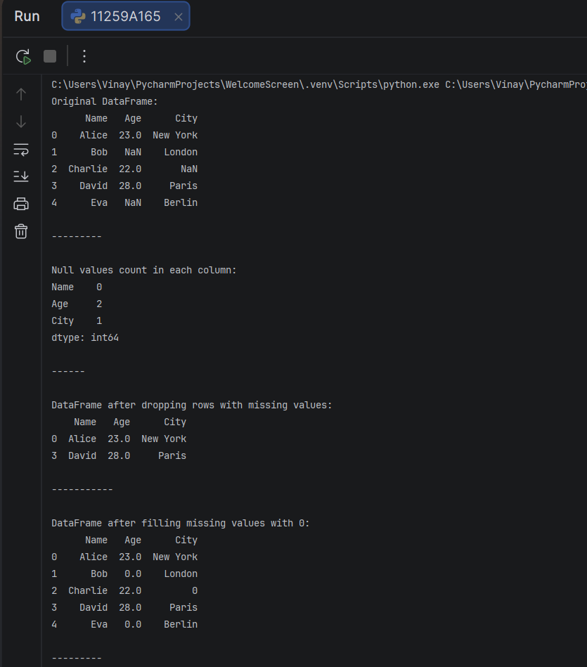
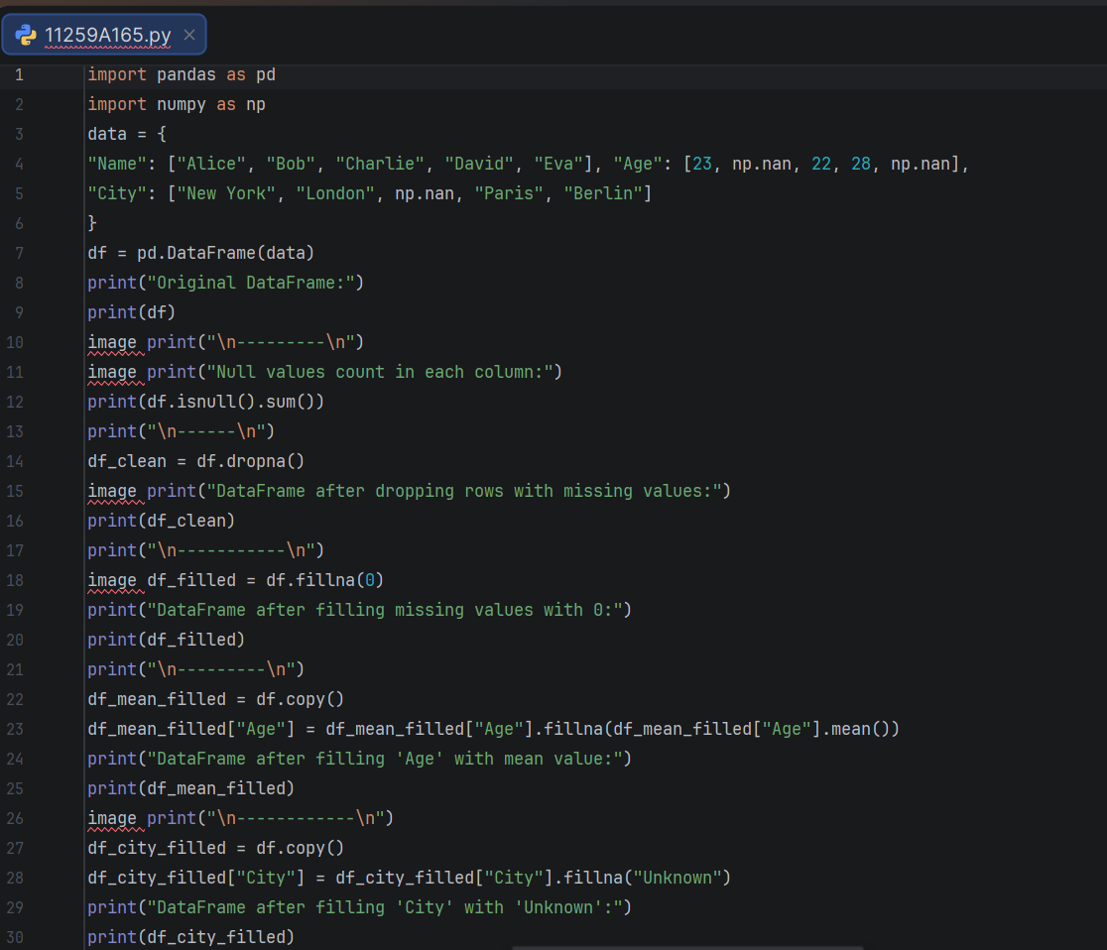
OUTPUT :

RESULT : Thus, the Pandas program was executed to identify and handle missing values in a DataFrame using different data-cleaning techniques. Missing values were counted, rows containing null values were removed, missing values were replaced with zero, missing ages were filled with the mean, and missing city names were replaced with "Unknown".

4. Matplotlib (Plotting Library)

AIM : To create a dataset using Pandas and visualize the relationship between study hours and exam scores using different types of graphs, such as a scatter plot, line plot, histogram, and bar chart, with the help of Matplotlib.

ALGORITHM :
- Start the program.
- Import the Pandas, NumPy, and Matplotlib libraries.
- Create a dataset containing StudyHours and ExamScore.
- Convert the dataset into a Pandas DataFrame.
- Scatter Plot:
- Plot study hours against exam scores using plt.scatter().
- Add axis labels and a title.
- Display the graph using plt.show().
- Line Plot:
- Plot study hours against exam scores using plt.plot() with circular markers.
- Add axis labels and a title.
- Display the graph.
- Histogram:
- Plot the distribution of exam scores using plt.hist() with two bins.
- Add axis labels and a title.
- Display the graph.
- Bar Chart:
- Plot study hours against exam scores using plt.bar().
- Add axis labels and a title.
- Display the graph.
- Stop the program.

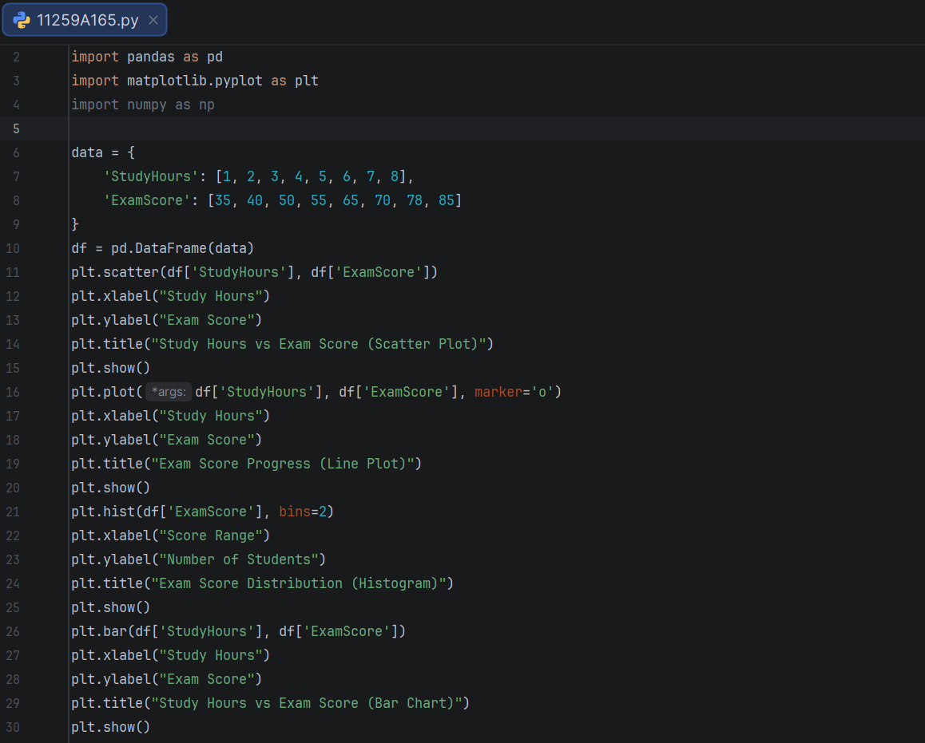
PROGRAM :

OUTPUT :

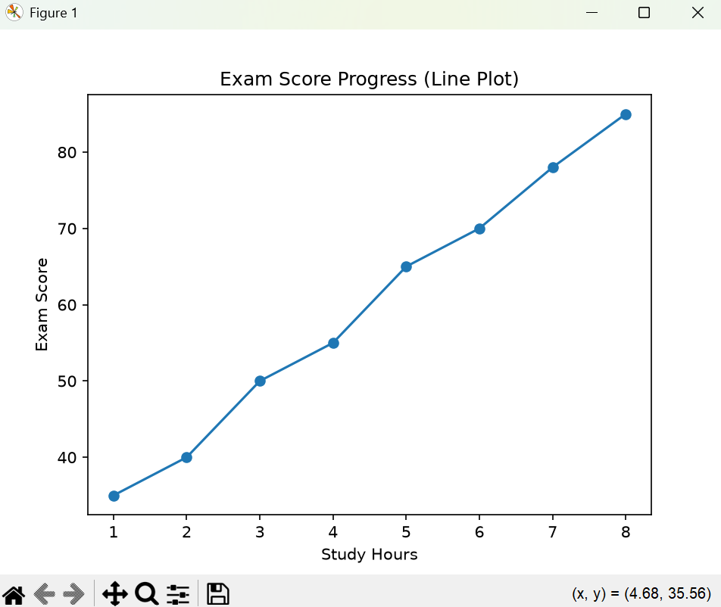
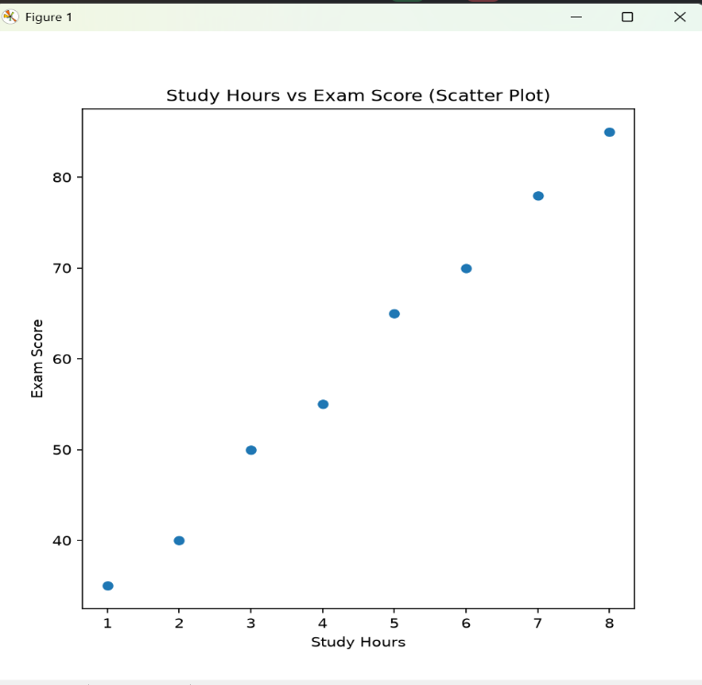

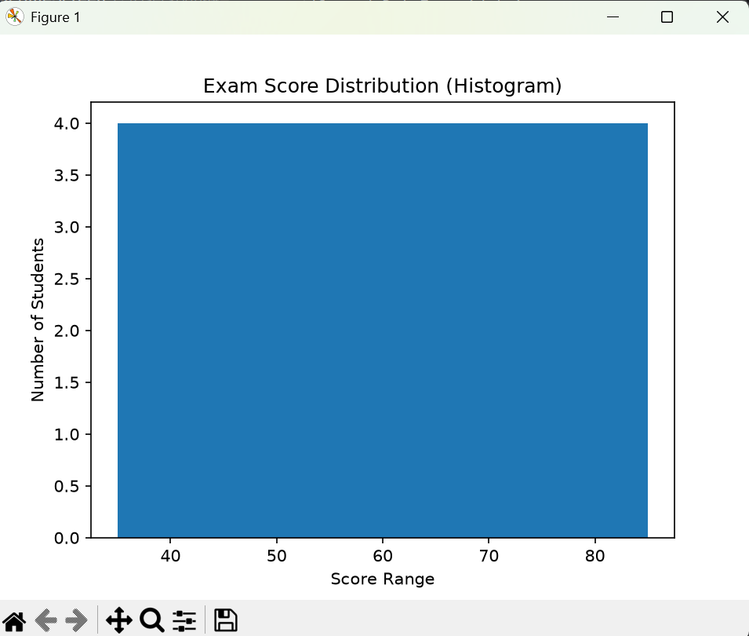
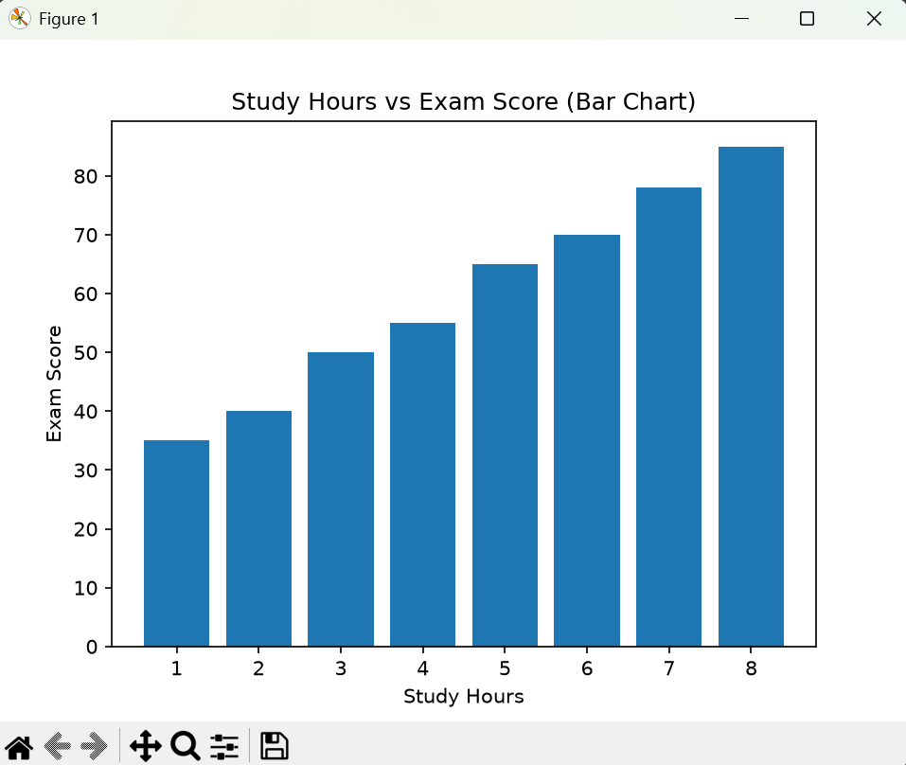

RESULT : Thus, the program was executed successfully to visualize the study hours and exam scores using four different graphs: a scatter plot, line plot, histogram, and bar chart. The graphs help identify the relationship between study hours and exam scores and understand the distribution of exam scores.

